“The Euro Crisis: Where to From Here?”

Jeffrey Frankel*
Forthcoming in Journal of Policy Modeling, May/June 2015.

Short abstract:

Germans cannot agree to unlimited bailouts of euro members. On the other hand, if they had rigidly insisted on the founding principles (fiscal constraints, “no bailout clause,” and low inflation as the sole goal of the ECB), the euro would not have survived the post-2009 crisis. The impact of fiscal austerity has been to raise debt/GDP ratios among periphery countries, not lower them. The eurozone will endure, but through a lost decade of growth. It would help if the ECB further eased monetary policy, which it could do by buying US treasury bonds if not eurozone bonds. Still needed is a long-run fiscal regime to address the moral hazard problem. Two worthwhile proposals are blue bonds and the delegation of forecasting to independent fiscal agencies.

Keywords: crisis, euro, blue bonds, fiscal, monetary, Greece
JEL classification numbers: F4, F33

* Jeffrey_Frankel@Harvard.edu. Harvard Kennedy School, Harvard University, 79 JFK Street, Cambridge, MA 02138. The author would like to thank Karl Kaiser, Hans-Helmut Kotz, Beatrice Weder di Mauro and Jesse Schreger for comments and Rémi Bourgeot and Jessica Stallings for data. This paper was written for a session When Will the Euro Crisis End? Organized by Dominick Salvatore, AEA Annual Meetings, Boston, January 3, 2015. Parts of this paper draw on “The Future of the Currency Union,” remarks prepared for Academic Consultants Meeting, Board of Governors of the Federal Reserve System, May 6, 2013, HKS RWP13-015; and on “Why the ECB Should Buy US Treasuries,” keynote speech, conference on The Political Economy of International Money, Common Currencies, Currency Wars and Exorbitant Privilege, Federal Reserve Bank of Dallas and Southern Methodist University, April 4, 2014.

- Introduction
It is useful to begin a discussion of the euro crisis by facing up to the problems inherent in monetary union. One possible view is that the inherent difficulties were so great that the euro was doomed to fail. But even if one takes the historic fact of European monetary union as given, a consideration of how it could have been pursued differently should precede a discussion of ideas for how to fix the flaws that have become evident in the crisis.

- Three Structural Problems
Three distinct sets of difficulties were structurally built into the monetary union from the beginning. Going forward, leaders have to deal with all three, one way or another:
- The asymmetry problem, arising from the inability of members to devalue.
- The fiscal problem, in particular the moral hazard from keeping fiscal policy primarily at the national level when monetary policy was moved to the euro-wide level. And
- The banking problem, similarly keeping banking supervision at the national level while moving monetary policy to the euro level.
Problem 1, asymmetry, is inherent in the concept of monetary union, was thoroughly anticipated in the Optimum Currency Area literature of the 1960s and was the main ground on which a majority of American economists were skeptical of European monetary union in the run-up to 1999. The literature said that a country shouldn’t give up the ability to respond to asymmetric (i.e., idiosyncratic) shocks, e.g., the freedom to respond to a local downturn by easing monetary policy and devaluing the currency, unless it can compensate with other mechanisms such as high labor mobility. These are mechanisms that Europe lacked.
Problem 2 is fiscal moral hazard. The architects of the euro in 1991 focused sharply on this to the surprise of most economists at the time. They put fiscal and debt limits at the heart of the Maastricht criteria for entry (3% of GDP and 60 %, respectively), they adopted a “No Bailout Clause,” and later they agreed the Stability and Growth Pact (SGP) and its successors. They deserve credit for recognizing the moral hazard problem early, because fiscal policy constraints had not previously been featured in the scholars’ lists of Optimum Currency Area criteria. Two huge qualifications, however, negate that kudos: (i) The elites were forced to do it politically. Voters in Germany -- often used in this paper as short-hand for Northern European creditor countries -- were opposed to the euro on the grounds that “we know you will have us bailing out a profligate Mediterranean government before you’re done.” (ii) Soon after the euro’s inauguration it became very clear that the attempt to address problem 2 had failed: that fiscal criteria were being violated continuously, that the SGP had no teeth and no credibility, and that – because Mediterranean country spreads relative to Germany had all but disappeared (Figure 1) – the markets must have believed that the ECB would bail out any countries that got into debt trouble. In other words, the moral hazard problem, though correctly identified, had not been effectively addressed. Virtually all members, big and small, had violated the fiscal criteria, well before the euro crisis began in late 2009.
Figure 1: Convergence of periphery-countries’ interest rates to Germany’s after they joined the euro suggests no perceived default risk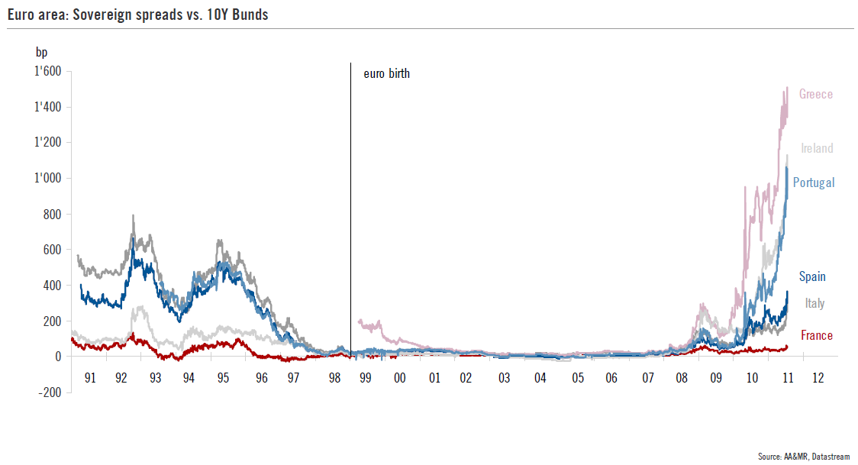

Problem 3, banking supervision, was at best mentioned in passing in the 1990s. Almost no thought was given to the possibility of moving deposit insurance, supervision, or bank resolution to the ECB level.

When crisis struck, the three kinds of failure and the causal connections among them featured with differing degrees of importance in different countries. At one end of the Eurozone, Greece was the purest example of a fiscal disaster. The Greek budget deficit in truth had never been brought below the 3% of GDP ceiling, nor did the 100% debt/GDP ratio ever even decline in the direction of the 60% limit as it was supposed to do. (See Figure 2). And it was in Greece that the sovereign debt problem burst forth in October 2009, kicking off the euro crisis, when the incoming government revealed that the 2009 budget deficit was not 3.7 per cent of GDP as previously claimed, but more like 13.7 per cent. There was a close connection between the Greeks’ fiscal problem and the erosion in competitiveness, as the national failure to live within their means translated into higher wages without productivity gains.

Figure 2: The Greek budget deficit had never come below the 3% of GDP ceiling,
nor did the 100% debt/GDP ratio ever decline in the direction of the 60% limit.
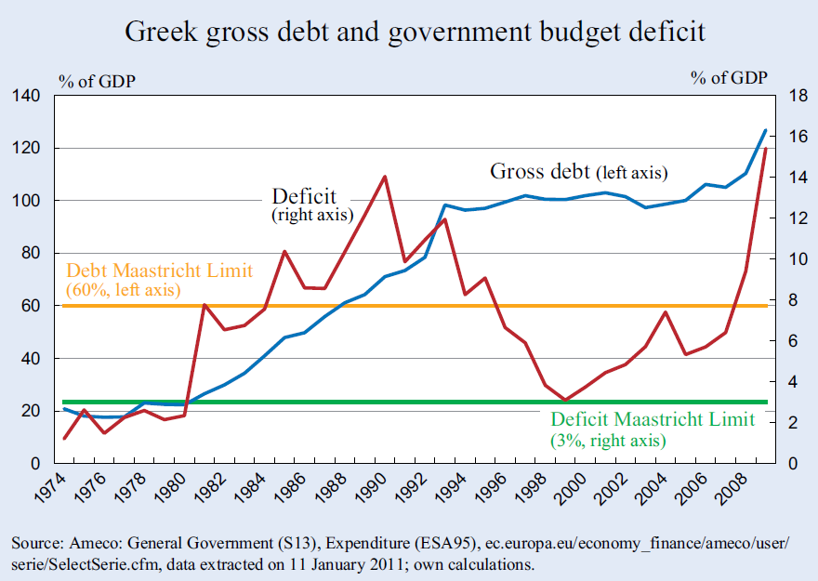

At the opposite end of the Eurozone, Ireland was in relatively good shape fiscally going into 2007. Its central problem arose in the housing and banking sectors. Here the inability to set a monetary policy appropriate to local conditions had been a major cause of the housing/banking problem: during the bubble period that preceded the 2007 collapse, Ireland clearly had needed tighter monetary policy, but the euro forced on it the interest rates set in Frankfurt. And the subsequent severe fiscal situation was the consequence of the banking collapse. The government’s ill-fated decision in September 2008 to guarantee all bank liabilities translated the banking crisis into a subsequent fiscal crisis. Reinhart and Rogoff (2009)’s historical observation that banking crises tend to be followed a few years later by sovereign debt crises gave us perhaps the most clairvoyant of the predictions in their celebrated book.
The trinity of structural flaws -- asymmetry, fiscal, and banking – is a useful way to organize analysis of the crisis and remedies. But one hears of a more colorful tripartite distinction based on national cultural proclivities: Some say that the critical problem is Mediterranean profligacy, others say it is German severity, and still others that it is Anglo-American financial markets.
It is important to sound a note of American humility and admit that under-recognized shortcomings in our financial markets did indeed give us the housing peak of 2006, the sub-prime mortage crisis of 2007, the global financial crisis of 2008, and the global recession of 2009, and that these events were in turn the trigger for the euro crisis of 2010-12. Having said that, however, let us move on. If the GFC had not been the shock that triggered the euro crisis, sooner or later it would have been something else.
That leaves us with the tension between profligacy and austerity. This tension is indeed central, both to the long-term structural problems, where the issue is preventing profligacy, and to the short-term macroeconomic situation, where faith in austerity has been grossly excessive.

- Addressing the Three Structural Problems
Let us now turn to the question what changes would be required for a more stable currency union. All three structural problems call for wrenching changes.
Just a paragraph on problem 3, banking. European leaders began to take steps in the right directions in 2012. One of them was the decision to move banking supervision functions from the national level to the level of the European Central Bank, though Germany has resisted moving supervision of all banks to the ECB level. The stress tests by the European Bank Authority in 2014 and simultaneous Asset Quality Review by the ECB were major steps forward.

Although federalizing banking supervision is not easy, addressing the other two problems is more difficult still.

Problem 1 is now the need to restore competitiveness in the periphery. Over the first decade of the euro, wages and unit labor costs (ULC) in Greece and other periphery countries rose relative to Germany’s (Figure 3). Their trade and current account balances had deteriorated correspondingly by 2007 (Figure 4), although these huge deficits at the time were widely viewed as a reflection of new optimizing capital flows rather than a symptom of lost competitiveness. If the periphery countries were to stay in the euro after 2010, the solution to the competitiveness problem was to reverse that decade of widening ULC gaps through some combination of painful wage reduction and productivity growth. We knew it can be done, because the three Baltic countries did it in response to the global financial crisis. (They paid the price in 2009 in the form of the worst recessions of anybody worldwide; but output and employment subsequently recovered.) They were willing to sacrifice a lot to join the euro. It has taken the Mediterranean countries many high-unemployment years to accomplish what the Baltics did in two years, and some are not there yet. “Fiscal devaluation” could help, for example a combination of reduction in payroll taxes and increase in Value Added Tax, but such measures are as unpopular as any.

Figure 3: During the euro’s first decade, wages & ULCs rose faster in the periphery than in Germany. During 2008-14 some of the gap was reversed.

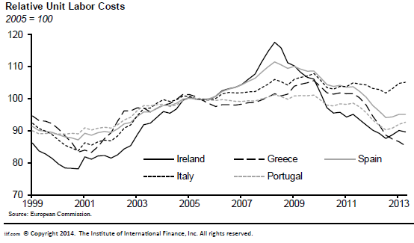
Source: Anderson and Stallings (2014).

Figure 4: Big current account deficits in periphery countries up to 2007 were seen as benign reflections of optimizing capital flows, instead of warning signals.

The productivity side is likely to be as difficult politically as the wage side, because it requires things like cutting bureaucratic red tape, opening up the professions, and liberalizing labor markets. The silver lining is that these are reforms that should have been done anyway, but that were not going to get done short of a severe and lasting crisis. They should have received more attention from the troika relative to austerity, because they can be good for output and employment rather than bad for it. Keynesians often argue that such supply-side reforms can only have a very slow impact over time. But allowing more shops to stay open on Sundays and liberalizing licensing for taxis and pharmacies, to take three small but salient examples, could boost employment almost immediately.
The fiscal problem was perhaps the most difficult of all. Just as was predicted by most independent economists, the fiscal austerity programs made the recessions much worse. (See Figure 5). As a result, debt/GDP ratios rose after 2009 (Figure 6) -- rather than falling, which was supposed to be the point of fiscal austerity in the first place. There was no way to get back to sustainable debt paths in some countries, without debt reductions such as the partial write-down that belatedly came about for Greece. Even five years after the euro crisis hit, there is still no plan for bringing debt/GDP ratios back down, other than running primary surpluses that seem impossibly ambitious.

Figure 5: Those enacting the biggest fiscal contractions suffered the biggest GDP losses
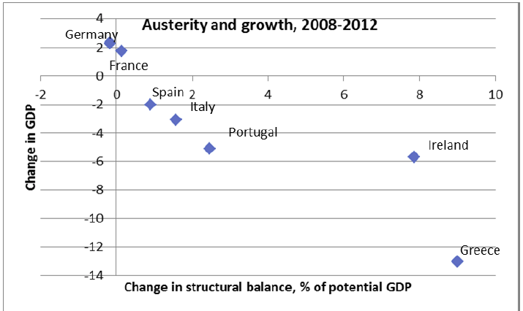
Source: Paul Krugman, “Euro Austerity, Continued,” blog, New York Times, April 28, 2012.

Figure 6: Debt/GDP ratios are rising sharply, as negative growth overpowered progress on reduction of primary budget deficits.

- Comparisons with the United States
Comparisons with the successful monetary union that is the United States are useful. Let us pause, however, for a second note of American humility: the US achieved fiscal incompetence after the turn of the century that was as bad as the Eurozone’s. We don’t even have the excuse of needing to reach agreement among 19 different national legislatures. That said, it is a close contest as to who has made more mistakes since 2001.
The grounds on which many economists were skeptical of EMU ex ante were specifically the correct observation that the prospective euro members did not satisfy the OCA criteria among themselves as well as the 50 American states did: trade, symmetry of shocks, labor mobility, market flexibility, or countercyclical cross-state fiscal transfers. Some Europeans thought that if they went ahead with European monetary union anyway, the loss of the monetary instrument would force increased flexibility of labor markets. This was mostly wrong -- think of the French 35-hour workweek -- unless the crisis finally helps to bring it about now in such countries as Greece and Italy.
The issue of fiscal moral hazard has turned out to be at least as relevant as the OCA criteria, however, and this is where I believe that European leaders should have been looking more carefully at the US example. After all, the US federal government has not bailed out a single state in two centuries. Nobody expects it to do so, no matter how deep a hole the state government in question gets itself into. How did the US vanquish state-level moral hazard?
The question is especially relevant with respect to crisis-era reforms, championed by German Chancellor Angela Merkel, that seek to give future enforceability and credibility to the Eurozone targets for deficits and debt, after the repeated earlier failures of the Stability and Growth Pact. The Fiscal Compact has technically been in effect since 2013. It sets deficit targets that are stricter than under the SGP, though at least they are specified in cyclically adjusted terms. Surveillance of national budgets includes a requirement that they be submitted ex ante to the EU Commission. And, as under its predecessor agreement the 2011 Euro-Plus Plan, countries are required permanently to put the euro-wide targets into their national laws and institutions. As rationale, some point to fiscal rules among the 50 individual American states, believing that they must be the explanation why we don’t suffer from moral hazard in state budgets. Others suggest that the explanation is the tendency for interest rate spreads on the debts of spendthrift American states to rise, long before debt/income ratios reach anything like European levels.
In my view, the state rules and the existence of spreads are best viewed as endogenous, the outcome of two structural decisions that were made long ago: First was the decision, made simultaneously and integrally with the ratification of the US Constitution in 1789, to move most spending and taxing powers from the states to the federal level. Second was the decision to let 8 states (plus Florida, then a territory) default on their debts in 1841-42 rather than bail them out, a critical precedent. These two structural features of the federal system mean that when the interest spread warning alarm is sounded, a state need only adjust spending or taxes by a few percentage points of income to get back on a stable debt path. In Europe, by the time the interest rate alarm had sounded it was too late: no primary budget surplus would have been big enough to get Greece back on a path of declining debt to GDP.
It is futile to identify as the euro’s key flaw the decision not to establish a fiscal union to match the monetary union as the US did in 1789. The 13 founding American states chose to ratify the US Constitution voluntarily, after a vigorous debate. European political majorities did not come close to favoring a fiscal union in the 1990s. Indeed they probably did not even support the euro, which is the reason why the elites always avoided asking the people’s opinion on the “European project” whenever possible. Moreover, it is unlikely that any Federalist Papers, no matter how cleverly written could change European public opinion on this score. After all, the public was right when it feared that it would eventually be asked to bail out a profligate country and the elite was wrong when they said they had the situation under control.
It is fair game however to argue that everything might have been different if Frankfurt and Brussels had reacted to the Greek debt crisis as Washington reacted to the southern states’ debt troubles in 1841. When the crisis erupted in Athens in late 2009 -- Prime Minister George Papandreou announcing the drastic correction to the budget numbers -- the European leaders should have seized on it as a golden opportunity, rather than wringing their hands. Why “golden opportunity”? They already knew that their attempts to deal with fiscal moral hazard had fallen short. So even the most optimistic among the leaders must have known that sometime during the euro’s life it would be challenged by fiscal troubles among one or more members. It was important to get the first case right, to set the correct precedent for the future.
Greece was the ideal test case, for two reasons. First, unlike Ireland or Spain, it was egregiously at fault. The Hellenic Republic would have been a natural place to draw a line, and its creditors were the natural ones to suffer losses. Second, unlike Italy, it was small enough that other governments and systemically important banks could have been protected from the consequences of a default with a fraction of the bailout money that has since been put up by the EFSF, the ESM, the EIB, and the ECB itself.
In early 2010 the leaders should have encouraged the Greeks to go to the IMF and, if necessary, to restructure their debts. Instead the ECB and the EC said at the time that going to the IMF and restructuring were both “unthinkable.” They thought that the precedents of emerging market crises in the 1980s and 1990s could not possibly hold any lessons for “advanced” European countries. Embarrassed, they swept the problem under the rug, kicked the can down the road, or – my preferred metaphor – stuck their ostrich heads into the sand. Their excuse was fear of contagion. But the result was that they made the eventual contagion much worse than it had to be. Given a small localized Greece fire and a natural fire-break separating it from the forest, they declined to make their stand at the fire-break and instead waited until it had spread and wide in the forest. By late 2010 the fire had spread to Portugal, Ireland and Spain; debt/GDP levels and sovereign spreads had climbed much higher, and the euro leaders had lost much of their credibility.

But that is looking back. We have been asked to look forward in this session. No one can predict what will happen. For what it’s worth, the Eurozone will survive. It has come too far to turn back now.

- Does Monetary Union Require Fiscal Integration?
Even though full fiscal union was not in the cards it became clear in 2010 that monetary union did require some fiscal integration that was not originally agreed at Maastricht. “More Europe” was inescapable. Returning to sustainable debt paths among some Mediterranean countries required additional purchases by the European authorities (ECB, EFSF, ESM, or EIB) of their bonds and/or write-downs. Given that by now most of the debt is either held by these same agencies or else by private banks that will need to be protected, restructuring will require some further de facto transfers, though it should also require national conditionality, as always.
But full fiscal union on the order of the US is not politically possible, certainly not in the short or medium run. Again: the German taxpayers who were afraid that the euro would lead to a fiscal bailout were proven right and the elites who assured them they had it all under control were proven wrong. Why should they believe them this time? Taxpayers in Germany (and the Netherlands, Finland, and Austria) have been forced to accept steps that look much like fiscal transfers, when confronted with the alternative of the breakup of euroland. The challenge is how to combine transfers today with a credible promise that there won’t be a repetition in the future. This problem is even more difficult to solve, at this late date, than the competitiveness problem. But the Europeans have to try, and I have some thoughts on how to go about it. The final section of the paper explains some ideas on how to avoid repetition in the future, in the long run, after the current debt burden has been addressed. But first we consider what more the ECB can do in the short run.

- Monetary policy
The ECB followed too tight a policy in the first years of the global financial crisis (2008-09) and of the euro crisis (2010-11). It relented after Mario Draghi became President in November 2011. Steps were taken to loosen monetary policy, restore effective functioning of the transmission mechanism, and restore confidence in the system. Specific measures included interest rate reductions, the Long Term Refinancing Operations of February 2012, the Outright Monetary Transactions announced in August 2012 (accompanied by the celebrated promise that “Within our mandate, the ECB is ready to do whatever it takes to preserve the euro,” which was so successful that OMTs turned out not to be needed), and an expressed willingness in 2014 to move to some form of quantitative easing in the near future.

Figure 7: GDP in the periphery countries lingers well below pre-crisis levels.
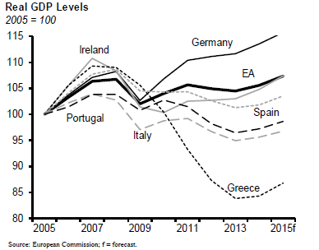

Source: Anderson and Stallings (2014).

Figure 8: Unemployment in the periphery countries lingers well above pre-crisis levels.
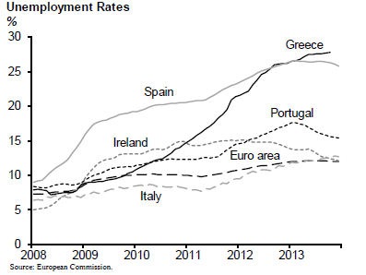
Source: Anderson and Stallings (2014).
Even seven years after the global financial crisis, output in the Greece, Spain, Portugal, Ireland and Italy remained well below pre-crisis levels (Figure 7) and unemployment remained well above (Fig. 8). Countries like Italy have been in a single big long recession ever since 2008 if one applies criteria similar to those used to date US recessions by the NBER Business Cycle Dating Committee. Inflation across the euro zone has been running below the target of “close to 2%;” at the time of writing, it has just turned negative. Further monetary stimulus is called for.
Yes, monetary easing is likely to mean higher inflation rates and more euro depreciation than would otherwise occur. But that would be the point: it would be especially difficult for the Mediterranean countries to improve their price competitiveness if they had to do it entirely through deflation. It would be easier if German inflation is allowed temporarily to go above 2%. Furthermore it will be much easier for them to improve their competitiveness globally if the euro depreciates. Finally, inflation and euro depreciation would also gradually help bring down debt/GDP ratios.
Of course inflation and depreciation give the Bundesbank heart attacks. Many Germans would put these two words on the same list of morally repugnant promise-breaking as debt write-downs, the very existence of the EFSF and ESM, and – worst of all – ECB purchases of troubled bonds. And in a sense they would be right. I am not one of those who belittle the Germans’ “morality tale” perspective as a cultural oddity. It is understandable, given the history. But if the euro is to survive (which is defined as France and Germany both staying in, at the very minimum), the Germans must give way on these things, even though they deliberately did not sign up for them at the beginning. And they especially must give way on the absurd premise that austerity is expansionary, as if we learned nothing from the 1930s. Probably they will indeed continue to give way, kicking and screaming the whole time.
- The ECB Could Do QE via FX
A proposal that the ECB buy US bonds strikes most as a radical notion. The ECB has never previously considered such a thing, let alone done it, and has not intervened in the foreign exchange markets in either direction in 15 years. But the idea should be viewed not only as not radical, but as rather natural.
As noted, it is widely recognized that the ECB should further ease monetary policy. Under current conditions it is hard for the periphery countries to bring their costs the rest of the way back down to internationally competitive levels as they need to do. If inflation is below 1% euro-wide, then the periphery countries have to suffer painful deflation.
The question is how the ECB can ease, since short-term interest rates are already low. The ECB is widely urged to undertake QE, following the path of the Fed and the Bank of Japan, expanding the money supply by buying the bonds of member countries.
QE presents a problem for the ECB, however, that the Fed and other central banks do not face. The euro zone has no centrally issued and traded Eurobond that the central bank could buy. (The next section discusses one particular proposal to create such a bond. But there is little prospect that a Eurobond will in fact be created in the near term.) The ECB can buy packaged private securities that have been rendered riskless, again following the US strategy under which quantitative easing included the Fed purchase of mortgage-backed securities guaranteed by the government. But the supply of suitable private euro securities apparently falls short of the quantity that the ECB needs to buy.
That seems to imply that the European central bank has to buy bonds of member governments, which in turn means taking implicit positions on the creditworthiness of their individual finances. Germans tend to feel that ECB purchases of bonds issued by Greece and other periphery countries constitute monetary financing of profligate governments and violate the laws under which the ECB was established. The legal obstacle is not merely an inconvenience but also represents a valid economic concern with the moral hazard that ECB bailouts present for members’ fiscal policies in the long term.
Fortunately, interest rates on the debt of Greece and other periphery countries have come down a lot since 2012. Since he took the helm at the ECB, Mario Draghi has brilliantly walked the fine line required for “doing what it takes” to keep the Eurozone together. (After all, there would be little point in preserving pristine principles in the Eurozone if the result were that it broke up.) Global investors “rotated into” euro periphery bonds in 2013, in retreat from EM bonds. Spain’s government has at times been able once again to borrow as cheaply as the US government! As of the time of writing, there is no need for the ECB specifically to support periphery bonds, especially if it would flirt with unconstitutionality and especially if quantities would be insufficient.
What, then, should the ECB buy, if is to expand the monetary base? If it cannot buy Euro securities, it could instead buy US treasury securities. Admittedly, this would constitute a return to intervention in the foreign exchange market.

Here are several reasons why the European monetary authority should consider buying US bonds.
First, it solves the problem of what to buy without raising legal obstacles. Operations in the foreign exchange market are well within the remit of the ECB. Second, they also do not pose moral hazard issues -- unless one thinks of the long-term moral hazard that the “exorbitant privilege” of printing the world’s international currency creates for US fiscal policy.
Third, ECB purchases of dollars would help push the foreign exchange value of the euro down against the dollar. Such foreign exchange operations among G-7 central banks have fallen into disuse in recent years, in part because of the theory that they don’t affect exchange rates except when they change money supplies. There is some evidence to the contrary, that even sterilized intervention can be effective, including for the euro. But in any case we are talking about an ECB purchase of dollars that would change the euro money supply. The increased supply of euros would lower their foreign exchange value.
Monetary expansion that depreciates the currency is effective. It is more effective than monetary expansion that does not, especially when there is no scope for pushing short-term interest rates much lower.
Depreciation of the euro would be the best medicine for restoring international price competitiveness to the periphery countries and bringing their export sectors back to health. Of course they would devalue on their own if they had not given up their currencies for the euro ten years before the crisis (and if it were not for their euro-denominated debt). Depreciation of the euro as a whole is the answer.
Central banks should and do choose their monetary policies primarily to serve the interests of their own economies. The interests of those who live in other parts of the world come second. But proposals to coordinate policies internationally for mutual benefit are fair. How would ECB purchases of dollar bonds e by the lights of G20 cooperation? Since 2013 the rest of the world has been worried about US interest rates going up, not coming down. After the Fed has stopped buying US treasury securities, it is a perfect time for the ECB to step in and buy some itself.
- Eurobond Solutions
Any solution to the fiscal crisis must meet two objectives, which conflict. One is short run and the other is long run.
The first necessary objective is to put Greece, Portugal, and other troubled countries back on sustainable debt paths, defined as a long-term trajectory where the ratio of debt to GDP is declining rather than rising. Austerity won’t restore debt sustainability. It has raised debt/GDP ratios, not lowered them. A write-down would do it, but would then create moral hazard and thus make even it even harder to satisfy the second necessary objective.
That second objective is to reform the system so as to make it less likely that similar debt crises will recur anew in the future. Long-run fiscal rectitude is indeed the way to accomplish this. But it is hard to commit today to fiscal rectitude in the future. Rules like the Maastricht criteria, no bailout clause and Stability and Growth Pact (SGP) didn’t work, because they were not enforceable. And for that reason, they were not credible from the beginning.
Eurobonds could be part of the solution, if designed properly to take into account fiscal fundamentals. These are bonds that would be the liability of euroland in the aggregate.
The creation of a standardized Eurobond market would bring a boost to help reform plans come together, which is badly needed in light of the damage that years of failed euro summits have done to official credibility. Even when the euro was at the height of its success before 2008, it suffered from lack of a counterpart to the US Treasury bill market. Bonds were issued only individually by the 17 member governments. This fragmentation slowed European financial integration and hindered any bid by the euro to rival the US dollar as international reserve currency. Central banks in China and other big developing countries are still desperate for a form in which to hold their foreign exchange reserves, an alternative to holding US government securities. US Treasury bills pay low interest rates and the value of the dollar has been on a downward average trend ever since President Nixon took the dollar off gold and devalued in 1971. Despite all of Europe’s problems, a Eurobond would be attractive to central bankers and other portfolio investors around the world, to diversify risk.
But that latent global demand for Eurobonds will not come forth unless they are by design backed up with solid economic and political fundamentals. Germany opposes Eurobonds on the sensible grounds that if individual national governments were allowed to issue them freely, the knowledge that somebody else was paying the bill would make the incentive to spend beyond their means worse than ever. This version of Eurobonds would be guaranteed to fail, both economically and politically.
A different version of the Eurobond proposal gained some traction in Germany in 2012. The German Council of Economic Experts – often called “wise men” – proposed a European Redemption Fund (Bofinger, et al, 2011). The plan would convert into de facto Eurobonds the existing debt of member nations in excess of 60% of GDP, the threshold specified in the Maastricht and SGP criteria. The ERF bonds would then be paid off over 25 years, thus settling the huge legacy problem. Steps toward this proposed solution to the short-term debt problem were to be paired – politically and logically – with approval of the Fiscal Compact which was supposed to solve the long-term problem.
But this seems backwards. Yes, any solution to save the euro indeed carries a further implicit price tag for German taxpayers. But to use Eurobonds as the mechanism for eliminating the big debt overhang looks like the nail in the coffin of the longer term objective of limiting moral hazard. It offers absolution precisely on the margin where countries in the future will in any case have the most trouble resisting the temptation to sin again, the margin where they cross the 60% threshold.
If the Fiscal Compact could be relied on as a firm constraint on future behavior, then fine. But there is no reason to believe that it would and every reason to believe that it would not. Why should the Fiscal Compact succeed where the Maastricht criteria failed, the “no bailout” clause failed, and the SGP failed? Rules don’t work without some enforcement mechanism. The problem with the SGP wasn’t that it wasn’t written strictly enough. The problem with the SGP was that no matter how many times a member government’s deficit or debt exceeded the specified limit, the country’s officials could always say that the gap was the fault of unexpected circumstances such as slow growth and low tax receipts and that they expect to do better next time.

Official forecasts of GDP and budget deficits are systematically biased in the optimistic direction, even more so among Eurozone governments than among other countries (Frankel, 2011; and other references cited therein). Greece is a particularly egregious case (Fig. 9), but most of the other euro members have also been overly optimistic, as Figure 10 illustrates. When a Eurozone government finds itself with a deficit above the 3% limit, it adjusts its forecast to show the deficit coming back down below the limit in the coming few years, without adjusting its actual policies (Frankel and Schreger, 2013). This statistically significant tendency is reduced when the country gives the fiscal forecasting job to an independent agency. This could be an important lesson for the design of institutions under the Fiscal Compact.

Figure 9: Greek official forecasts were always over-optimistic. 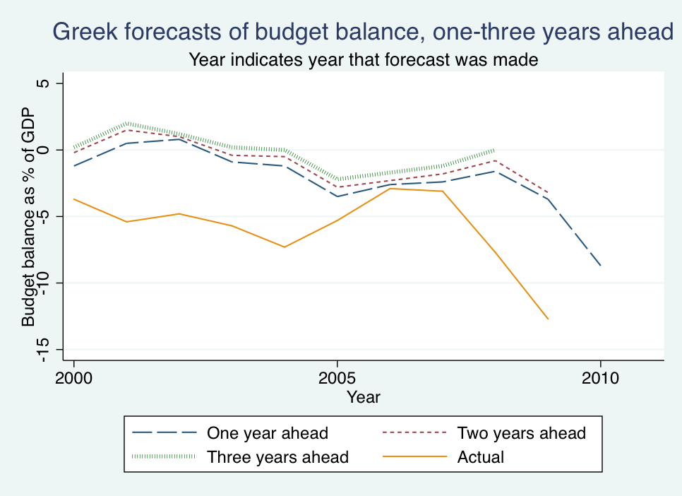
Source: Frankel and Schreger (2013).

Figure 10: Mean 2-year ahead official budget forecast errors.
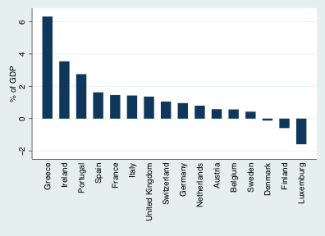

Source: Frankel &Schreger (2013).
A penalty of having to make up the difference next year does not improve credibility. Even if some court in Brussels or Frankfurt were given life-and-death power to enforce the rules, who exactly would it punish, and how? No version of the SGP or Fiscal Compact has ever provided a credible answer to that question.

The version of Eurobonds that might work is almost the reverse of the German wisemen’s proposal. It goes under the name of “blue bonds,” proposed by Delpla and von Weizäcker (2010). Under this plan, only debt issued by national authorities below the 60% criteria would receive Eurozone backing and effectively become Eurobonds. These are the “blue bonds” that would be viewed as safe by investors. When a country issued debt above the 60% threshold, the resulting “red bonds” would lose Eurozone backing. The individual member state would be liable for them.
As I see it, the private markets could make the judgment as to whether a country was in the process of crossing the 60% threshold, even before the final statistics were available, and therefore whether a new default risk required an interest rate premium. If private investors judged that the new debt had genuinely been incurred in temporary circumstances beyond the government’s control (say, a weather disaster), then they would not impose a large interest rate penalty. Otherwise, the sovereign risk premium would operate, much as it does among American states, and much as it did in Italy, Greece and the others before they joined the euro. The point is that the mechanism would be truly automatic, as desired. Perhaps in ambiguous borderline cases the judgment whether a country had truly exceeded the limit would ultimately have to be made by a court. But private investors would not wait; they would act from moment to moment on informed views about the merits. The resulting market interest rates would provide the missing discipline. Compliance would not rely on discretionary letters from Brussels bureaucrats, which have been proven toothless no matter how many exclamation points are put at the end of their penalty threats.

The euro countries cannot jump to a blue bond regime without first solving the debt overhang problem that is front and center. Unsustainable debt paths in many countries resulted from the combination of debt/GDP ratios that were already in excess of 60%, high sovereign spreads in the most troubled countries, and negative growth rates.
Eurobonds are not the solution to these vexing problems. It is hard to say, at this late date, what the right short-term solutions are. Easier euro-wide monetary policy should help. In Greece’s case, it may be forced to restructure again. Most of its bonds are held by public institutions such as the ECB and IMF, which don’t write down debts. But maturities could be further stretched out – conditional, one hopes, on structural reform rather than more fiscal austerity.
But one thing seems clear. German taxpayers will not be happy when asked to put up still more money in the cause of European integration by the same elites whose assurances of the last 20 years have proven false. They will at a minimum need some credible reason to believe that future repetitions in the future have been rendered unlikely, that the bailout is “just this once.” Official assurances do not constitute that credible reason. The red bonds / blue bonds scheme just might.

References

Aizenman, Joshua, and Yothin Jinjarik, 2012, “The Fiscal Stimulus of 2009-10: Trade Openness, Fiscal Space and Exchange Rate Adjustment,” NBER International Seminar on Macroeconomics 2011, J.Frankel and C.Pissarides, eds. (University of Chicago Press).

Alesina, Alberto, and Roberto Perotti, 2010, “Germany Spending is not the Cure,” in Completing the Eurozone Rescue: What More Needs to Be Done? edited by Richard Baldwin, Daniel Gros, Luc Laeven (CEPR: London).
Anderson, Jeffrey, and Jessica Stallings, 2014, “Euro Area Periphery: Crisis Eased But Not Over” (Institute of International Finance), Feb. 13.
Auerbach, Alan, and Yuriy Gorodnichenko, 2012, “Fiscal Multipliers in Recession and Expansion,” in Fiscal Policy after the Financial Crisis, Alberto Alesina and Francesco Giavazzi, eds. (University of Chicago Press).
Batini, Nicoletta, Giovanni Callegari and Giovanni Melina, 2012, “Successful Austerity in the US, Europe and Japan,” International Monetary Fund Working Paper No. 12/190 July.
Beetsma, Roel, and Harald Uhlig, 1999, “An Analysis of the Stability and Growth Pact,” Economic Journal 109 (458): 546–71.
Blanchard, Olivier, and Daniel Leigh, 2013, “ Growth forecast errors and fiscal multipliers,” American Economic Review, 103(3), May:117-120.
Blanchard, Olivier, and Francesco Giavazzi, 2002, “Current Account Deficits in the Euro Area: The End of the Feldstein–Horioka Puzzle?” Brookings Papers on Economic Activity, no. 2, pp. 147–86.
Bofinger, Peter, Lars Feld, Wolfgang Franz, Christoph Schmidt, and Beatrice Weder di Mauro, 2011, “A European Redemption Pact,” VoxEU, November 9.
Buiter, Willem, Giancarlo Corsetti and Nouriel Roubini, 1993, “Excessive Deficits: Sense and Nonsense in the Treaty of Maastricht,” Economic Policy, Vol.16,57-100
De Grauwe, Paul, 2000, Economics of Monetary Union (Oxford University Press).
Delpla, Jacques, and Jakob von Weizäcker, 2010, “The Blue Bond Proposal,” Bruegel Policy Brief, issue 2010/03, May.
--- 2005, “Europe, the Euro and the ECB: Monetary Success, Fiscal Failure,” Journal of Policy Modeling, 27(4), 427-439.
--- 2010, “The Breakup of the Euro Area" in Europe and the Euro, edited by Alberto Alesina and Francesco Giavazzi (The University of Chicago Press: Chicago).
Eichengreen, Barry, and Ugo Panizza, 2014, “A Surplus of Ambition: Can Europe Rely on Large Primary Surpluses to Solve Its Debt Problem?” CEPR Discussion Paper 10069; NBER WP 20136.
Farhi, Emmanuel, Gita Gopinath and Oleg Itskhoki, 2014, “Fiscal Devaluations,” Review of Economic Studies 81.2: 725-760. NBER WP 17662.
Fatas, Antonio, and Ilian Mihov. 2001. “The Effects of Fiscal Policy on Consumption and Employment: Theory and Evidence,” Centre for Economic Policy Research Discussion Paper 27670.
Fatum, Rasmus, and Michael Hutchison. 2002. “ECB Foreign Exchange Intervention and the Euro: Institutional Framework, News, and Intervention.” Open Economies Review. 13 (4), Oct., pp. 413-425.
Feldstein, Martin, 1997, "EMU and International Conflict." Foreign Affairs:76, no.6, 60-73.
--- 2005. "The Euro and the Stability Pact." Journal of Policy Modeling 27.4, 421-426.
--- 2012. "The Failure of the Euro," Foreign Affairs 91.1: 105-116.
Frankel, Jeffrey. 1993. “ ‘Excessive Deficits: Sense and Nonsense in the Treaty of Maastricht;’ Comments on Buiter, Corsetti and Roubini,” Economic Policy, Vol.16, 92-97
--- 2010. "Let Greece Go to the IMF." Jeff Frankel’s blog, 2/11/10.
--- 2011. “Over-optimism in Forecasts by Official Budget Agencies and Its Implications," Oxford Review of Economic Policy. vol.27, no.4, pp.536-562. NBER WP 17239.
--- 2012. “Could Eurobonds Be the Answer to the Euro Crisis?” VoxEU, June 27.
--- 2014a. “The ECB Should Do QE via FX,” VoxEU, March 24.
--- 2014b. “Italian Growth: New Recession or Six-Year Decline?” VoxEU, August 11.
Frankel, Jeffrey, and Jesse Schreger. 2013. "Over-optimistic Official Forecasts in the Eurozone and Fiscal Rules." Review of World Economy, Vol. 149,no.2 (Kiel, Germany), 247-272. NBER WP 18283.
Jonung, Lars, and Eoin Drea. 2009. “The Euro: It Can’t Happen, It’s a Bad Idea, It Won’t Last. U.S. Economists on the EMU 1989-2002." European Economy. Economic Papers 395. Dec. (Brussels).
Lane, Philip. 2011. “The Irish Crisis” in The Euro Area and The Financial Crisis. edited by Miroslav Beblavy, David Cobham, and L’udovit Odor (Cambridge University Press), pp. 59–80.
--- 2012. "The European Sovereign Debt Crisis." Journal of Economic Perspectives. vol.26, no.3, pp.49–68.
McKinnon, Ronald. 1963. "Optimum Currency Areas" American Economic Review, 53, September, 717-724.
Mundell, Robert. 1961. "A Theory of Optimum Currency Areas." American Economic Review, 51, no. 4, November, 509-517.
Reinhart, Carmen, and Kenneth Rogoff. 2009. This Time Is Different: Eight Centuries of Financial Folly (Princeton University Press).
Shambaugh, Jay. 2012. “The Euro’s Three Crises.” Brookings Papers on Economic Activity, no. 2, Spring
Uhlig, Harald. 2010. “Euro Area Business Cycle Dating Committee: Determination of the 2009 Q2 Trough in Economic Activity”, VoxEU, 4 October.
Woodford, Michael. 2011. “Simple Analytics of the Government Expenditure Multiplier.” American Economic Journal: Macroeconomics. 3 (1), pp. 1–35.
Wyplosz, Charles. “Bailouts: the next step up?” VoxEU, 21 February 2009.

Feldstein (1997, 2012) predicted that the monetary union would be a source of political conflict among its members, the opposite of a major motivation for the project.
These are similar to the three crises in Shambaugh (2012). See also De Grauwe (2000) and Lane (2011).
As related by Jonung and Drea (2009). Interestingly, the originators of the Optimum Currency Area criteria -- McKinnon (1963) and Mundell (1961), both born Canadian -- were more supportive of European Monetary Union and fixed exchange rates than the American critics.
E.g., Buiter, Corsetti and Roubini (1993); Frankel (1993); Beetsma and Uhlig (1999).
E.g., Eichengreen (2005), Feldstein (2005).
E.g., Blanchard and Giavazzi (2002).
E.g., Farhi, Gopinath and Itskhoki (2014).
Alesina and Perotti (2010).
Among much relevant research: Fatas and Mihov (2001), Woodford (2011), Auerbach and Gorodnichenko (2012), Aizenman and Jinjarik (2012), Batini, Callegari and Melina (2012), and Blanchard and Leigh (2013) .
How can one decry both the budget deficits of 2002-07 and the fiscal austerity of 2009-14? Like any sensible economist, I prefer counter-cyclical fiscal policy to pro-cyclical.
Primary surpluses in excess of 5 per cent of GDP, for ten years. This is unlikely to be achievable, according to the historical record in Eichengreen and Panizza (2014).
“Nineteen” counts Lithuania, which joined the Eurozone January 1, 2015.
Major labor reforms did take place in the Netherlands, followed in 2002 by Germany’s Hartz reforms under Chancellor Gerhard Schröder. But these are not readily characterized as structural convergence to facilitate EMU.
E.g., Lane (2012).
This is not hindsight: Wyplosz (2009) and Frankel (2010, 2011).
E.g. Eichengreen (2010).
The mechanical rule that everyone instead uses in Europe says that a single quarter of above-zero growth marks the end of a recession, no matter how big the declines in GDP immediately before and after, so that Italy is supposedly in its third recession in six years. Frankel (2014b) and Uhlig (2010).
Frankel(2014a).
E.g., Fatum and Hutchison (2002)
Frankel (2012) .

